Math 2413 – Calculus I ***Homework*** (Lecture 4)

Professor Khoury

Find each *indefinite* integral

**1.**  **2.**  **3.** 

Find each *definite* integral

**3.**  **4.** 

**5.** 

**6.** Find the total areas of the shaded regions

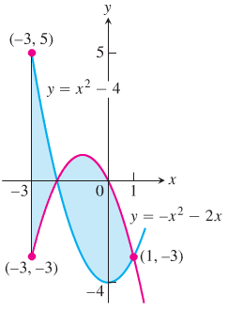

**7.** Find the area of the region bounded by the graphs of  and 